**Shop Nest Store Power BI Capstone Report – In-Depth Analysis**

**1. Total Sales by Product Category**

**Observations:**

* The **Agro Industry and Commerce** category leads in total sales, surpassing all other categories.
* **Air Conditioning, Art, and Arts & Craftsmanship** categories also contribute significantly to revenue.
* Categories such as **Books (Technical & Imported), CDs/DVDs/Musicals, and Christmas Supplies** generate lower sales.

**Insights:**

* The top-performing categories likely have **consistent demand** or cater to **seasonal necessities** (e.g., Air Conditioning sales may peak during hot months).
* Low-performing categories may suffer from **niche audience appeal, lack of promotions, or low inventory levels**.

**Recommendations:**

* Increase **advertising and promotional efforts** on high-performing categories to maximize revenue.
* For low-performing categories, consider **seasonal discounts, bundling, or phasing out slow-moving products**.
* Conduct a **customer demand analysis** for books, CDs, and Christmas supplies to determine whether pricing or visibility issues are affecting sales.

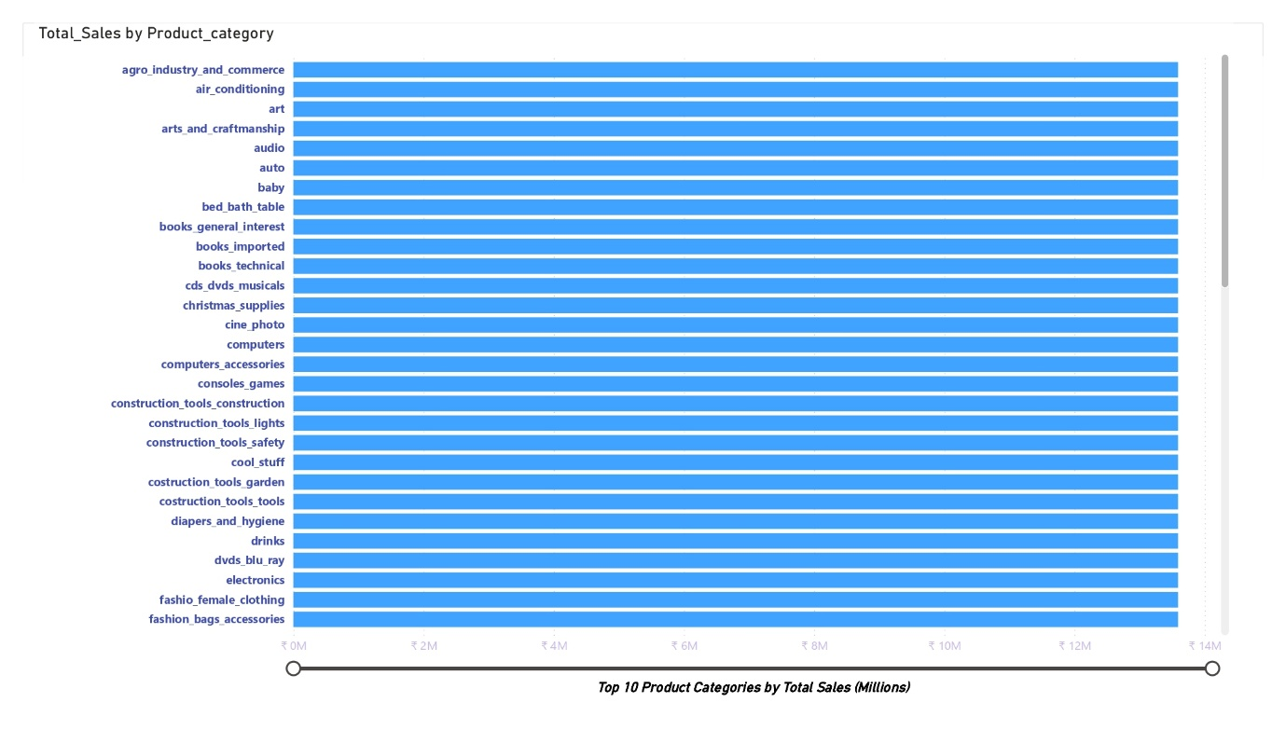

**2. Order Volume and Delays Over Time**

**Observations:**

* Order volume **peaked in November 2017 and May 2018**.
* **Fluctuations** in order volume are observed, possibly due to **seasonal demand, promotions, or economic factors**.
* Although the majority of orders were delivered on time, **a noticeable portion was delayed**.

**Insights:**

* The **spike in orders in Q4 2017** suggests a strong **holiday or year-end shopping trend**.
* The presence of delays could indicate **logistical bottlenecks, supplier issues, or fulfillment inefficiencies**.

**Recommendations:**

* Investigate the root causes of **delayed orders**, such as supplier lead times, warehouse processing speeds, and shipping provider efficiency.
* Implement **predictive analytics** to forecast order surges and optimize inventory and logistics accordingly.
* Strengthen partnerships with **reliable logistics providers** to reduce delivery delays.

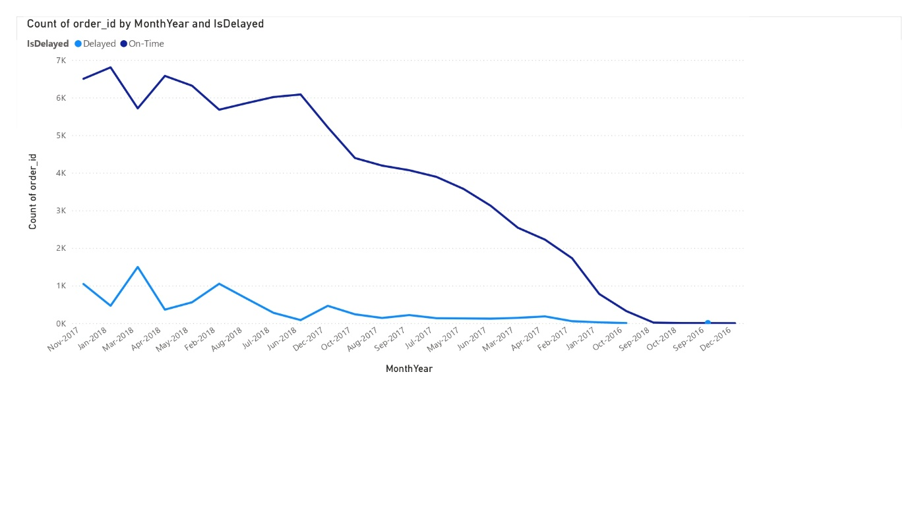

**3. Payment Method Distribution**

**Observations:**

* **73.92% of transactions** were made via **credit card**.
* **Boleto (bank slips)** accounted for **19.04%**, indicating a strong presence of traditional payment preferences.
* **Vouchers and debit cards** had significantly lower usage, at **5.56% and 1.47%, respectively**.

**Insights:**

* The dominance of **credit cards** suggests that customers prefer the **convenience and potential installment plans**.
* The **19% share of Boleto payments** suggests a customer base that may prefer deferred or offline payment methods.
* Low usage of **debit cards** and **vouchers** indicates potential barriers in usability or lack of promotional incentives.

**Recommendations:**

* Introduce **discounts or cashback incentives** for debit card payments to boost adoption.
* Offer **exclusive promotions for Boleto users** to encourage repeat purchases.
* Evaluate if additional payment options like **digital wallets (e.g., PayPal, Google Pay, or Apple Pay)** could improve checkout conversion rates.

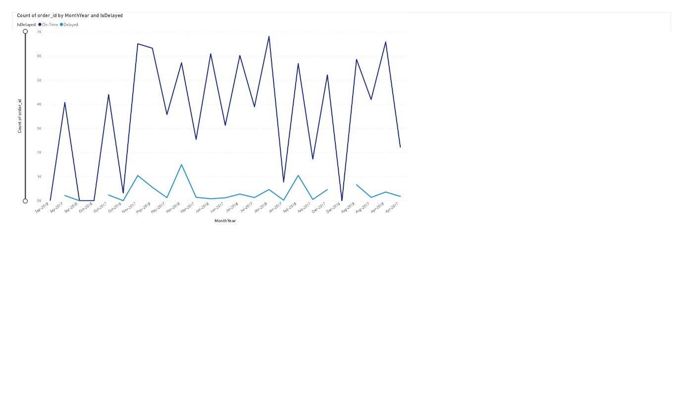

**4. Product Ratings Distribution**

**Observations:**

* Product ratings vary between **2 to 4 stars**, with no clear indication of extremely high or low-rated products.
* A significant number of products have average ratings.

**Insights:**

* Products with **lower ratings (below 3 stars)** may indicate **quality or fulfillment issues**.
* The lack of products with **exceptionally high ratings (near 5 stars)** could suggest **room for product or service improvements**.

**Recommendations:**

* Identify products with **consistently low ratings** and assess customer feedback for **quality improvements**.
* Encourage customers to **leave reviews** by offering incentives such as **discounts or loyalty points**.
* Work on improving the **customer service experience** to address common complaints before they affect ratings.

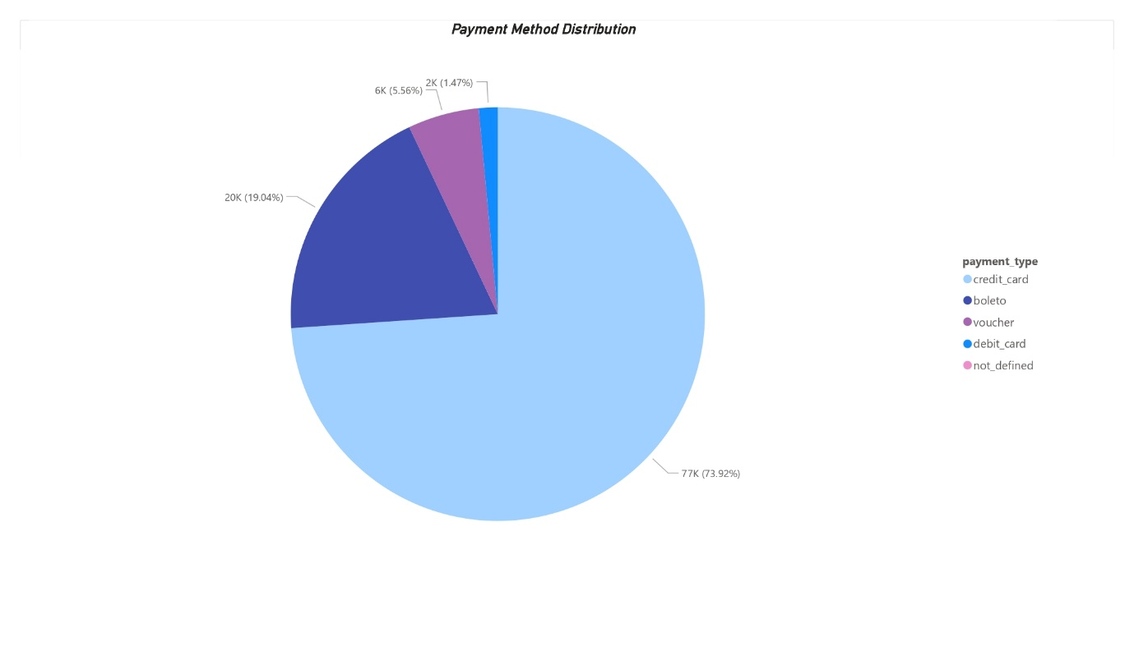

**5. Total Sales by State**

**Observations:**

* The **highest sales** were recorded in **São Paulo (SP), Rio de Janeiro (RJ), and Rio Grande do Sul (RS)**.
* Lower sales were observed in **states like Goiás (GO), Espírito Santo (ES), and Distrito Federal (DF)**.

**Insights:**

* **SP, RJ, and RS** are high-population, high-income states, naturally contributing to higher sales.
* The lower sales in **GO, ES, and DF** may be due to **lower brand penetration, weaker demand, or inadequate logistics**.

**Recommendations:**

* **Increase localized marketing efforts** in lower-performing states.
* Analyze shipping costs and **logistics efficiency in low-sales states** to see if **delivery times are impacting sales**.
* Consider **state-specific discounts or promotional campaigns** to drive sales in underperforming regions.

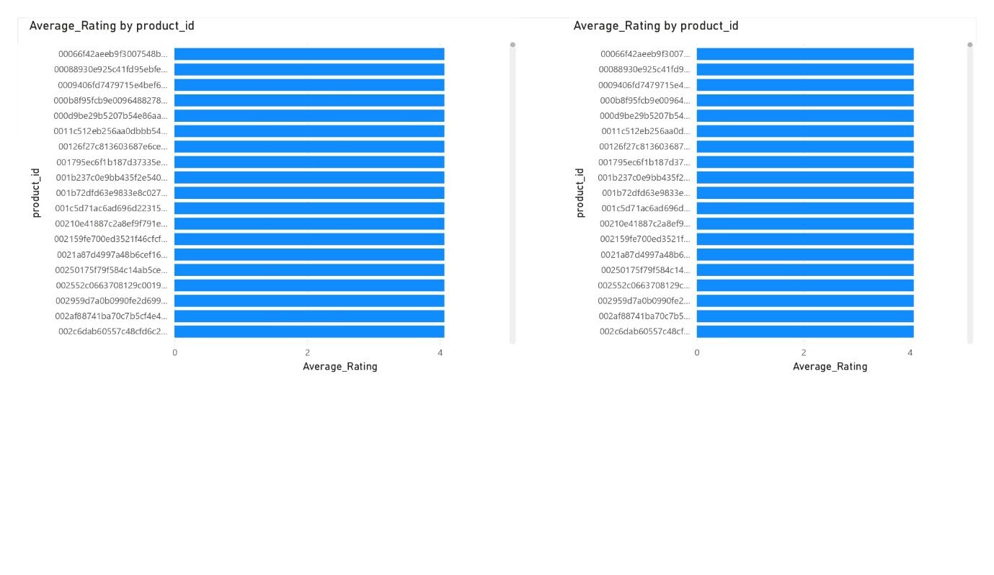

**6. Total Sales by Quarter**

**Observations:**

* Sales peaked in **Q4 2017**, with a noticeable drop in **Q1 2017**.
* Q3 and Q4 generally performed better than Q1 and Q2.

**Insights:**

* The **Q4 peak** aligns with **holiday shopping seasons and year-end sales**.
* The **dip in Q1** could indicate a **post-holiday slump** where customers reduce spending.

**Recommendations:**

* Implement **Q1 retention strategies**, such as **New Year discounts or loyalty programs**, to maintain momentum.
* Invest in **pre-holiday advertising** to capture more sales in Q4.
* Use **historical sales data** to predict and **optimize inventory levels for peak seasons**.

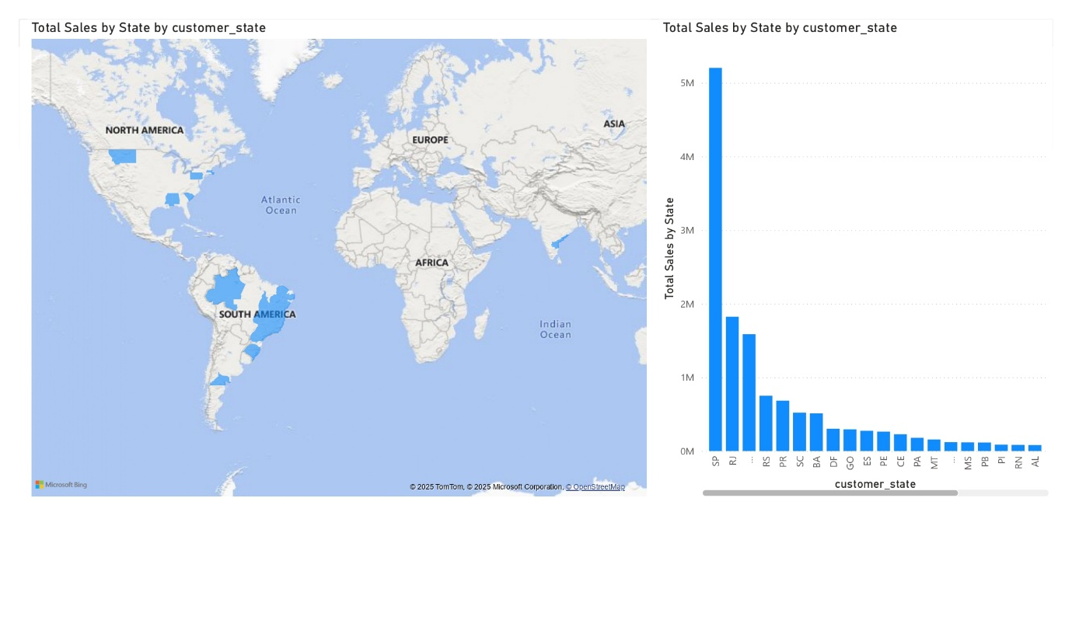

**7. Total Revenue by Year**

**Observations:**

* Revenue has shown a **steady increase** from 2016 to 2018.
* 2018 had the **highest recorded revenue**, while 2016 had the lowest.

**Insights:**

* The **growth trend** indicates a **successful expansion of the customer base**.
* The increase in revenue suggests **effective marketing and product strategies** over the years.

**Recommendations:**

* Analyze **which factors contributed to revenue growth** and refine successful strategies.
* Ensure that **supply chain scalability** can keep up with increasing demand.
* Continue **data-driven marketing campaigns** to sustain revenue growth in future years.

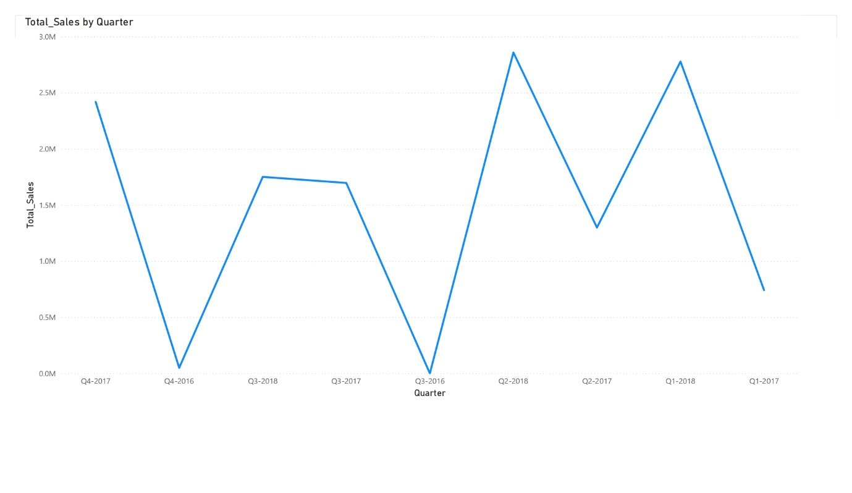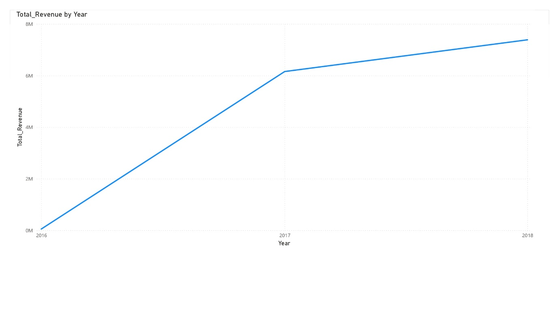

**Recommendations & Strategic Takeaways**

1. **Focus on Best-Selling Product Categories** – Expand stock and marketing efforts for high-performing categories while phasing out low-demand products.
2. **Reduce Order Delays** – Optimize logistics and supply chain efficiency to improve delivery times.
3. **Diversify Payment Method Promotions** – Encourage debit card and alternative payment usage to capture a broader audience.
4. **Improve Customer Ratings** – Address low-rated products and actively encourage customer reviews.
5. **Expand into Lower-Sales States** – Strengthen marketing and logistics strategies in underperforming regions.
6. **Leverage Seasonal Trends** – Maximize Q4 sales opportunities while minimizing Q1 revenue drops.
7. **Ensure Scalability** – As revenue increases, ensure operations, inventory, and logistics can keep up with demand.